|  |  |
| --- | --- |
|  | **Eastern Goldfields College**  **Year 11 Specialist Mathematics**  **INVESTIGATION 1 2019** |

**Total Marks33 Minutes: 40 Name:**

**Part 1 (10 Marks)**

a) The expression contains two terms and hence is called a binomial. Complete the following, writing the expanded version in powers of  and powers of  (gathering like terms). The first 3 have been done for you and the 4th has been partially completed. (5 Marks)













b) What do you notice in the powers of a? (1 Mark)

c) What do you notice in the powers of b? (1 Mark)

d) Looking at the patterns found above and ignoring the coefficients (numbers in front of the variables), complete the following general rule for the expansion of  (2 Marks)



(ie the first 3 terms and the last 2 terms)

e) How many terms are there in the expansion of  (1 Mark)

**Part 2 (11 Marks)**

The method for determining the coefficients can be found if they are written in a triangular array.

a) Copy and complete this triangular array. (2 Marks)

With 

 1

 1 1

 1 2 1







b) How do the numbers is the above array relate to the coefficients of the terms when you expanded the binomials in Question 1 part A? (1 Mark)

c) This Triangular array is called Pascal’s Triangle. Although it allows us to find the coefficients it is time consuming and a little painful. To find a particular row of coefficients we need a preceding row. (4 Marks)

Write down the expansion of

i) 

ii) 

d) Is there a better way? Complete the following (2 Marks)

   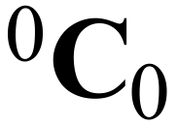

 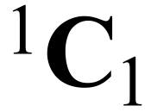 

 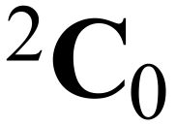 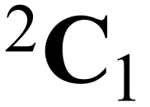 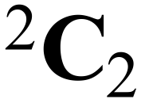

 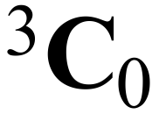 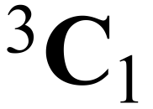 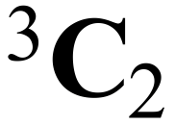 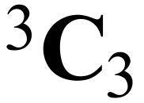





e) In General (2 Marks)



**Part 3 (12 Marks)**

From your observations in Part A and Part B

a) Expand (Hint: let  and ) (3 Marks)

b) Expand  (4 Marks)



c) Write down the first 3 terms of (2 Marks)



d) Consider the expansion of

i) How many terms are there? (1 Mark)

ii) Find the middle term. (2 Marks)